**University of Houston-Clear Lake**



Computer Information Systems

Case Study Analysis on

**Apple Inc.**

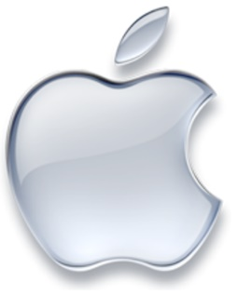

**Submitted By**

Fenil Desani (1510467)

Tamma Nishchal Reddy (1565239)

Vinaykumar Shivaraddi Jatteppanavar (1560218)

**Under the Guidance of**

Dr. Wei Wei

Computer Information System

University of Houston Clear-Lake

**Table of Contents**

|  |  |  |
| --- | --- | --- |
| **Sl. No.** | **Name** | **Page No.** |
| 1 | Executive Summary | 01 |
|  |  |  |
| 2 | Case Analysis | 02-10 |
|  | 2.1 Business Strategy | 02 |
|  | 2.1.1 Vision Statement | 02 |
|  | 2.1.2 Mission Statement | 02 |
|  | 2.2 Five Forces model analysis (Porter’s Model) | 02 |
|  | 2.2.1 Bargaining Power of Buyers/Customers | 03 |
|  | 2.2.2 Bargaining Power of Suppliers | 04 |
|  | 2.2.3 Threat of Substitute Products | 04 |
|  | 2.2.4 Potential Threat of New Entrants | 04 |
|  | 2.2.5 Industry Competitors | 04 |
|  | 2.3 Value Chain Model | 05 |
|  | 2.4 Organizational Structure | 06 |
|  | 2.5 Organizational Culture | 06 |
|  | 2.6 Financial Evaluation | 07 |
|  | 2.7 Supply Chain Management | 08 |
|  | 2.8 Green Apple | 08 |
|  | 2.9 SWOT Analysis | 09 |
|  | 2.10 Success Factors | 09 |
|  |  |  |
| 3 | Future of Apple Watch | 10 |
|  |  |  |
| 4 | Major Takeaways | 10 |
|  |  |  |
|  | References | 12 |

**List of Figures**

|  |  |  |
| --- | --- | --- |
| **Figure No.** | **Figure Name** | **Page No.** |
| 1 | Five Forces Analysis (Porter’s Model) | 03 |
| 2 | Apple Inc. Suppliers | 05 |
| 3 | Apple’s Executive Team | 06 |
| 4 | Twitter Reaction on Apple Watch vs Other smart watch | 07 |
| 5 | shows the smartwatch market share by | 07 |
| 6 | Supply Chain Management of Apple Inc | 08 |
| 7 | Environment friendly features of Apple watch | 09 |

**1. Executive Summary**

Apple Inc., formerly known as Apple Computer, was founded by Steve Jobs and Steve Wozniak, and 20 college dropouts, on 1st April 1976. Per Forbes’s list of most valuable brands in the world, for 2016, Apple leads the chart with a value of whopping $154.1 billion, 87% more than the second ranked Google. [1]

From beginning, Apple Inc. steered by Steve jobs, believed in closed systems with end-to-end control. This proved to be a major success strategy for the company. The Apple’s timeline of products starts from Apple 1, launched in 1976. Later, with a mission to bring easy-to-use computers in the market, Apple 2 was launched in April 1978. By 1980, more than 100,000 units of Apple 2 were sold, making Apple the industry leader in PC market. In 1984, Apple launched Macintosh, in response to IBM’s open system PCs, which marked the breakthrough in ease of use, industrial design, and technical specification. However, due to closed system and high selling price, Apple suffered huge losses. This lead to changes the at Apple Inc. and co-founder, Steve Jobs was forced out of the company in 1985.

From 1985 to 1996, Apple suffered huge losses and at one point it was on the verge of bankruptcy within 90 days. The company tried changing the upper management with new CEO’s such as John Sculley, Michael Spindler, and Gilbert Amelio. Apple even tried changing their strategy from closed system to open systems, they changed their price-differentiation strategy to low cost PC models and they even collaborated with their rivals, IBM, and Microsoft. However, all their strategies failed, and Apple was on the verge of bankruptcy. In December 1996, Amelio announced the acquisition of NeXT software (founded by Jobs after he left Apple) and plans to develop a new OS based on NeXT. To save the company from bankruptcy, Jobs became interim CEO of Apple in September 1997. [2]

Jobs quickly reshaped Apple by bringing back old strategies such as, closed-systems and price-differentiation. He also, considered focus as an important strategy and cut down to 4 product lines from 15. In 1998, he hired Tim Cook, to streamline Apple’s supply chain. This approach led to Job’s first real coup – the iMac – introduced in August 1998. This was again a turning point for Apple, as Apple posted a $309 million profit in fiscal year 1998 after launch of iMac, reversing the previous year’s $1billion loss.

In 2001, Job’s presented his vision for Macintosh in what he called the “digital hub”. Apple’s digital-hub strategy was realized by the debut of iPod in 2001, followed by iPhone in 2007, and then iPad in 2010. It also launched iTunes to integrate iPod, iPad, and PC, App Store to bring variety of applications to users, and iCloud for cloud storage. In September 2014, under the leadership of new CEO Tim Cook, Apple launched new line of products namely Apple Watch – a smart watch, and Apple Pay – a smart way of payment using Apple products such as iPhone and Apple Watch,. In Cook’s first three years as CEO, the stock price of Apple nearly doubled, while revenues went up to 70%. In 2015, Apple’s market capitalization surpassed $700 billion, making it the most valuable company in the history of the world. However, majority of profit Apple created was only through iPhone. [2]

The success of Apple can be accounted to the strategies used by them. Firstly, they used priced-differentiation strategy which helped them incur huge profits. Secondly, they focused only on few products rather than a pool of products. Third, they decided to use closed-systems making their own applications, hardware, and software. Fourth strategy is innovation, which lies at the center of Apple’s vision. Fifth, they stand out in the market by having a green line of products – environment friendly. Lastly, they decided to spend more on R&D department than any of other world leading company does. These few common strategies have enabled Apple to stay at the top. But the question is what new line of products would Apple be able to bring in future? Would current products remain to be as successful as they are? Can Tim Cook carry forward the legacy and values of Apple created by Steve Jobs? The case below provides an analysis of the strategies in detail.

**2. Case Analysis**

**2.1 Business Strategy**

The success of Apple Inc., are the business strategies they use which can be clearly seen in their vision and mission statement. Innovation and simplicity with elegance are at the center of Apple’s strategy making paradigm. These two notion can also be seen in their vision statement, which clearly defines the strategic direction of Apple and what CEO wants to achieve in the future. Though Apple does not have any clearly stated vision statement, CEO Tim Cook stated in an interview:

**2.1.1 Vision Statement** [3]

“We believe that we are on the face of the earth to make great products and that's not changing. We are constantly focusing on innovating. We believe in the simple not the complex. We believe that we need to own and control the primary technologies behind the products that we make, and participate only in markets where we can make a significant contribution. We believe in saying no to thousands of projects, so that we can really focus on the few that are truly important and meaningful to us. We believe in deep collaboration and cross-pollination of our groups, which allow us to innovate in a way that others cannot. And frankly, we don't settle for anything less than excellence in every group in the company, and we have the self-honesty to admit when we're wrong and the courage to change. And I think regardless of who is in what job those values are so embedded in this company that Apple will do extremely well.”

Apple’s vision statement clearly speaks what approach it has taken in shaping the company’s future. Innovation is the key business strategy of Apple which can be considered to be a value cultivated by Steve Jobs. Another important thing mentioned in the statement is simplicity. Apple highly believes in bringing the best user experience with ease-of-use; yet hardcore computing behind the tenderness. These traits can be easily found in revolutionary iPod, ground-breaking smartphones – iPhone, and state-of-the-art Apple Watch.

**2.1.2 Mission Statement** [3]

Apple’s mission statement is very specific in indicating what the company does and will do. Based on the changing technology and market, its mission statement has also changed over time. Apple’s current mission statement is:

“Apple designs Macs, the best personal computers in the world, along with OS X, iLife, iWork and professional software. Apple leads the digital music revolution with its iPods and iTunes online store. Apple has reinvented the mobile phone with its revolutionary iPhone and App Store, and is defining the future of mobile media and computing devices with iPad”

Apple’s mission statement includes its current line of products, which helps in determining what it provides to the customer and setting the baseline for future actions that Apple will implement. The mission statement also includes details about what Apple intends to do in its various businesses in future - “defining the future of mobile media and computing devices.” This clearly shows how Apple’s R&D would change the future of mobile media and other computing devices. Apple Watch and Apple Pay are clear examples of changing technology. Apple’s renowned analyst Ming-Chi Kuo said in a note to investors received by 9to5Mac that Apple might sell between 120 million and 150 million iPhone 8 units in the second half of next year. He added, that the OLED iPhone 8 will represent Apple’s major redesign, while the iPhone 8 and iPhone 8 Plus would be iterative updates to the current iPhone 7 and iPhone 7 Plus. [4]

**2.2 Five Forces Model Analysis (Porter’s Model)**

Founded in 1976, Apple Inc., formerly known as Apple Computers, is one of the most successful and valuable company in the world. Apple’s Five Forces analysis (Porter’s model) gives insights about how does the firm deal with external forces such as new entrants, bargaining power of suppliers, bargaining power of buyers, substitute products, and industry competitors. It also throws light on how does the company maintain its competitive edge despite dynamic changes in external forces and technology.

To retain leadership, Apple needs to focus thoroughly on few of the strong forces it faces from the external environment, and take into them into consideration while defining changes. Taking about Apple watch and Apple Pay, and the future of Apple Inc., the analysis is as shown in Figure 1.

Figure 1: Five Forces Analysis (Porter’s Model)

**2.2.1 Bargaining Power of Buyers/Customers**

The bargaining power of buyers is a strong force in the case for Apple, as it can easily change the company’s future. This strong force comes from:

* Customers can easily shift to low-cost cellphones.
* Buyers can opt for open systems such as Android OS.
* Competition from other companies in terms innovation, strong marketing, etc.

Apple balances this strong force with its various strategies such as:

* Cost-differentiation strategy.
* Already establishes brand image.
* Focus on innovative technology and customer loyalty.

**2.2.2 Bargaining Power of Suppliers**

The bargaining power of suppliers in comparatively weak force for Apple Inc., this is because of the following:

* Multiple suppliers like Intel, and Qualcomm for its hardware.
* End-to-end tie-up with the company like Foxconn.
* High number of parts supplied.

This weak force allows Apple to exploit its supplier base and achieve greater profits by bargaining with them. Also, as the number of supplies is higher and there is end-to-end integration between the companies, its undesirable for suppliers to break apart.

**2.2.3 Threat of Substitute Products**

The threat of substitute is a considerable weak forcefor Apple because of the following reasons:

* Apple uses closed system for its products.
* It is hard to replicate exact product with user interface like Apple.
* It offers all the current technology in one package.

Apple has a policy of making closed systems and hard to clone systems. Though many look-alike products are available, one can simply not replicate the exact product. With high price, they also provide innovative and a set of technologies in one package, which would not be feasible for another substitute product to deliver.

**2.2.4 Potential Threat of New Entrants**

The threat of new entrants can be considered as comparatively moderate force as new companies are constantly innovating and delivering products at par with Apple. The reason for considering it moderate force are:

* Companies providing same technology at low cost. Example, Pebble and Samsung smart-watch.
* Companies like Xiaomi, are already establishing their market in countries like China.

Apple can easily overcome this force, as it would be very difficult for an entrant to get established in the market and compete with the industry leader. However, it must take care that companies like Samsung which was once, new entrant to the smartphone industry is now the industry competitor for Apple. Few of the major benefits for considering this force as moderate are:

* New entrants would require high capital investment to establish and create Apple like products.
* High cost of brand development and compete with the already industry leader.

**2.2.5 Industry Competitors**

In this ever-changing technological world, it is very important for the companies to grab any opportunity that may come their way and create competitive advantage to be ahead of others. Industry competitors is a strong force for Apple Inc. as it is constantly in competition with companies like Google, Xiaomi, and Samsung. It is considered as strong force because of the following reasons:

* Competitors making similar and sometimes better products compared to Apple
* They provide same technology for low cost.
* As Apple, they are also well established companies in the market, with lots of capital and R&D to change things around.

Apple stands out from other competitors in this case by applying strategies such as:

* Making innovation their prime business strategy.
* They believe in making green (environment friendly) products.
* Their strategy of making things simpler yet packed with power performance makes their products stand apart. Example, Apple watch.
* Creating new services whose domain has not been explored yet. Example, Apple Pay.

**2.3 Value Chain Model**

Apple’s Value chain model is precisely defined and shows how various primary activities are been supported by Support activities. The various section of the model are as follows:

|  |
| --- |
| **Primary activities** |
| Inbound Logistics | * The major supplier of Apple Inc. is Foxconn which is located in Longhua, China.[5] * Automated receiving and storage system is in place to receive and store the inbound logistics |
| Operations | Apple Inc. companies operations are carried out by its trusted employees. |
| Outbound Logistics | The distribution is through online stores, retail stores, direct sales. |
| Marketing and sales | The sales are performed in 4 different modes, namely, online store ,retail, direct sale force, Network carriers. |
| Service | Customer service is exceptional as this company provides service in all three stages: pre-purchase, purchase, and post purchase. |
| **Support Activities** |
| Organization | The organization follows closed-door policy. |
| Human Resource | Training of staff and staff planning for division of specific labor. |
| Technology | Product testing, R&D and marketing divisions provide the required technology support. |
| Purchasing | The organization gets its supply from United States, China, Japan, Taiwan, Malaysia, South Korea and others, as illustrated in the Figure 2 |

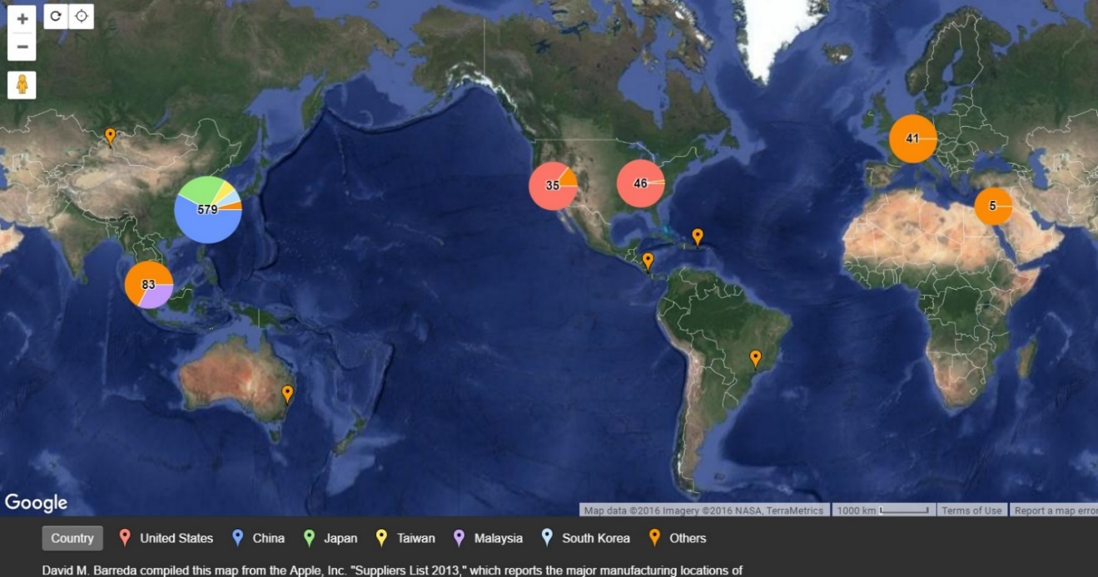

Figure 2: Apple Inc. Suppliers [6]

**2.4 Organizational Structure**

Apple’s organizational structure is mainly a centralized, and traditional hierarchy. This traditional structure can be seen from the very beginning of Apple Computer, where most of the decision were taken by upper management, majorly by Steve Jobs. The organizational structure plays an important role in the New Product Development (NPD) process, which is the key strategy for Apple. Though there a few changes made to suit the market and maximize the profits, the company largely believes in hierarchical and centralized structure as it accelerates the innovation process, quicker business decision, and provides a strong leadership to the company. Apple’s Executive Team is as shown in the Figure 3.[7]

Though, Apple has a hierarchical structure, there are various horizontal sub groups in the upper management which facilitates the business of Apple. Each sub-group is being handled by a Senior Vice President, who in turn oversees, vice presidents and working-groups under them.

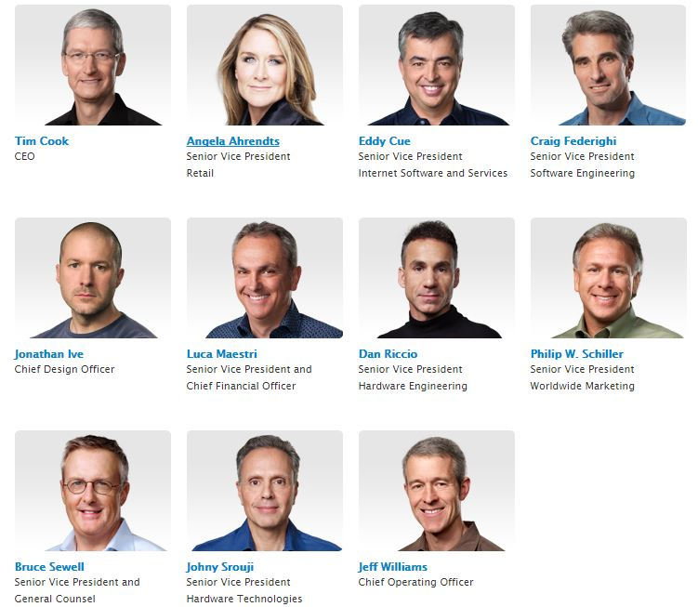

Figure 3: Apple’s Executive Team [8]

**2.5 Organizational Culture**

The work culture is mainly depended on the trust of the employee. The work culture is such that only the trusted employees were allowed to get key cards. Apple followed a close door policy wherein the newly hired employees were made to work on dummy projects. Only when the trust was gained from the employees they were deployed on real projects. Apple Inc. follows an organizational culture where in the employees felt the work was rewarding, which at the same time was difficult. The organization had tough policies for secrecy and violating the work culture of the company resulted in termination. [9]

**2.6 Financial Evaluation**

Apple Watch and Apple Pay: Cook introduced Apple Watch and Apple Pay in September 2014 and Apple entered into wearable technology. The Apple watch had to be charged everyday and it worked only with the new iPhones and it was expensive: prices started from $349 for the basic model and ranged as high as $17000. There were already significant competition in the market by other companies. Apple introduced Apple pay on the same day and most of the nation’s largest banks and credit card companies had signed up to support it. By early 2015 dozens of retailers had pledged to accept Apple pay in their stores. Apple hoped that that the combination of security and convenience would encourage rapid uptake of technology. Cook claimed in December that Apple pay accounted for two-third of mobile payments at participating retailers. Nearly 2 million customers had added their cards to their Apple pay account. The reaction on Twitter for Apple watch Vs other smart watches in shown below:

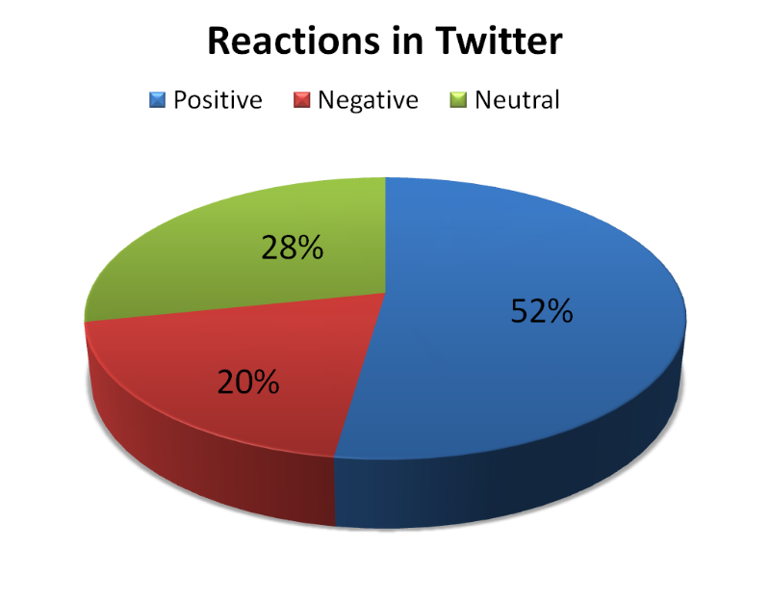

Figure 4: Twitter Reaction on Apple Watch vs Other smart watch [10]

Figure 5 shows the smartwatch market share by OS, which shows that by 2020, Apple Watch will have the largest market share.

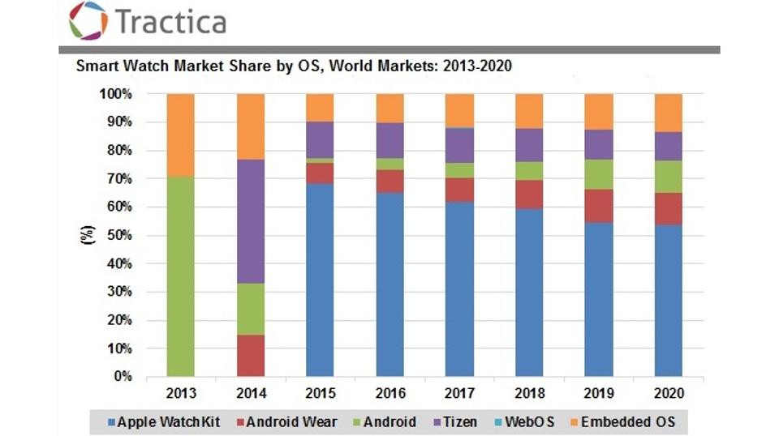

Figure 5 shows the smartwatch market share by OS [11]

**2.7 Supply Chain Management**

The supply chain of Apple Inc. is as illustrated in the Figure 6

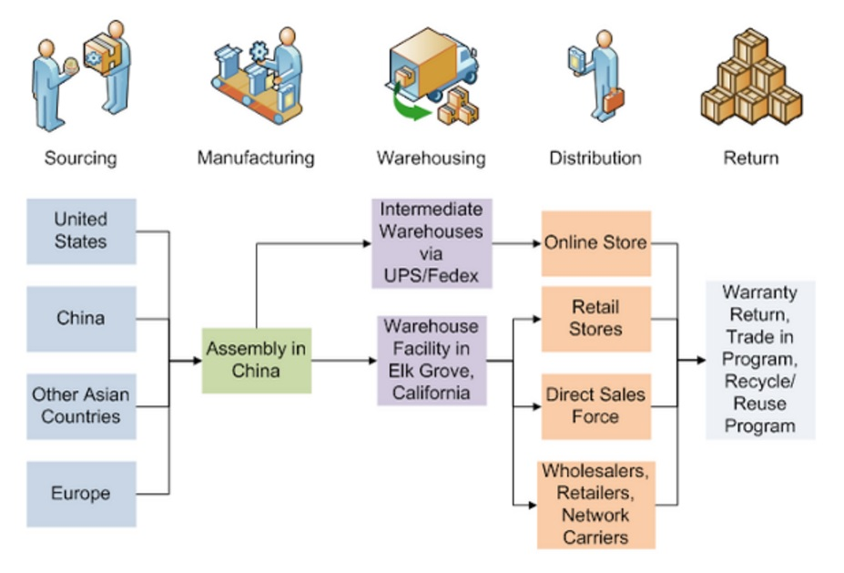Figure 6: Supply Chain Management of Apple Inc. [12]

**2.8 Green Apple** [11]

Apple has appointed Lisa P Jackson as Vice President, Environment, Policy, and Social initiatives to produce environmental friendly products. Apple Inc. is addressing the green materials usage for safer products. Few of the initiatives taken up are listed below:

* Conduction of product Life Cycle Assessment (LCA): This is used to identify and analyze components of iPhone with respect to potential impacts on environment.
* Use of external verification and assurances: A check for carbon emission related products.
* ISO 14001 certification: This is the standards for establishing an organization which has Environmental Management System (EMS).
* Banning of environmental sensitive substance: Environmental sensitive substances are banned from use in Apple products, packing and manufacturing.
* Restriction on use of lead: Apple phased out use of lead in plastic, paint, and packing materials.
* Apple follows REACH regulations: The Registration, Evaluation, Authorization and Restriction of Chemicals Regulation (REACH) regulates the safe use of chemical. Apple is complying with these REACH regulations.
* No use of Ozone Depletion Substances (ODS).
* Apple offer recycling of any apple devices.

The features of Apple watch contributing to greener environment is as illustrated in Figure 7.

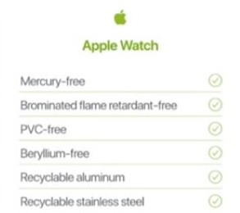

Figure 7: Environment friendly features of Apple watch. [13]

**2.9 SWOT Analysis**

The main strength of Apple Inc. lies in its innovations. The emphasis on R&D department by the company has resulted in bring up newer technology into phone, computers, music players and watches. Apply always finds a new product when its shares are dipping. The company has not relied on a single product for its success. It has produced new product when needed. The new product is always accompanied with a unique feature which is attracts customers.

Another key strength of Apple is its distribution system which directly links with the customers. The customers of Apple Inc. are more loyal which helped them to sell the Macintosh at a premium price.

The weakness of this company lies in its failure to reduce the cost of the products. The apple watch costed $349 whereas Pebble sold similar watches for $150. The company has tried many ways in order to reduce the production cost by introducing licensing programs which was started by Spindler in order to reduce 16% work force which would result in reduced production cost of products. The cost of products are also increasing because of the companies investment of 9% sale in R&D where as other companies are such as Compaq is investing 5% and IBM-Clone is investing 1%.

The opportunities are being created because the company is entering newer markets with its new products. For example, the entry of Apple Inc. to phone market when there were existing companies which had already excelled in those market.

Threats faced by Apple Inc. is more. The innovative ideas like apple store brought up by Apple were also included by Google’s android in play store. The alternate products which the competitive company is coming up with is also of lower costs. Hence the major threat is by the competing companies coming up with the same ideas with cheaper price of products.

**2.10 Success Factors**

**Innovation:** The separate R&D department in this company has resulted in bring up technology in computers, phones, watches, music devices. Coming up with new ideas such as itunes music store in iPod’s, integrating: iPod with touch screen; secondary revolutionary mobile phones; and breakthrough in internet communications, and apple pay in Apple watch has resulted to their success even though the prices of products are comparatively high.

**Buyers and Distribution:** Apple outlets has resulted in buying of products directly by customers.

**Multimillion-Dollar Marketing Campaign:** Promotion of products by a company reflects in the sells. Apple came up with two such campaign namely, think different and catchy slogans. This helped in the promotions of their products and its features over other products.

**Looking to Compete in Newer Market:** Apple introduced iPhones which was the successor of their iPod product. At the time of entry to mobile market there were already well establish companies in this market such as Motorola, Samsung, etc. Also, the introduction of Apple watch which was a competition for watches produced by Pebble. This is a success factor because entry in new market increase the variety of products being produced and results in broader domain of business. Focusing on single product will not result in improving market shares.

**3. Future of Apple Watch**[14]

Apple's future absolutely lies in concentrating on the smartwatches in light of the fact that the smartwatch market is the most talked about thing, which Apple has as of now infiltrated into with a little level of progress. The truth of the matter is, that numerous contenders are as of now out there in the market, with Pebble being the primary organization to present their smartwatch in mid-2013. Samsung kept up the biggest piece of the overall industry in 2013 and 2014, with the alternative of the least expensive smartwatch with an open-source OS, offering at $199. The significant test for Apple will convey more esteem with its smartwatch than any other merchant to keep up the biggest income—if not advertise, share.

Apple has been for some time known for keeping one of the most astounding edges in offering its products. With contenders, for example, Google's Android wear and Samsung offering around 4000 applications on their watches Apple needs to reconsider about their App Store for Apple Watch. Different issues, for example, drowsy execution of the watch over Bluetooth, shorter battery life, absence of application similarity and improvement – something which Android has better tended to with its Android wear, and that's just the beginning, remain the more extensive issues that Apple has thought little of in return for a heavier concentrate on the feel of the watch.

The best arrangement, as it appears, is continue with rolling out the product improvements on the OS level of the watch, since that way the Apple watch can hold its style and take after its plan limitations, furthermore, in the meantime enhance the battery life – since the applications would expend considerably less battery due to the streamlining. Since this arrangement would require the specialists to locate a superior method for deciphering the applications from the telephone to the watch, the recently created innovation could serve as leeway to what's to come updates of the watch. This would naturally increment the quantity of application choices accessible in the App-Store for the watch, and would address the issue of the absence of application decisions for the watch. Not just will clients have more choices to browse, however they will likewise have elegantly composed applications selective to the watch, at last enhancing the experience to far more prominent degrees.

**4 Major Takeaways**

The strategies applied by Apple Inc. have leveraged them to the most valuable brand in the world. These strategies can be summarized as follows:

1. Innovation
2. Price differentiation
3. Focus on products
4. Simplicity and ease-of-use
5. Closed system with end-to-end integration
6. Green line of products
7. Focus on Research & Development
8. Limited line of products

One cannot deny the fact that these strategies helped them achieve great feats but the question would remain would Apple Watch and Apple Pay can take forward the company as iPhone and App Store have been able to? Based on the above analysis, we can note that they though Apple Watch is ranked second best smart watch, how long would it be able to survive. Would Apple Pay revolutionize the payment system is still a question, as it is still in the years and though, people have registered, the number of users using the technology is vague. The only option left with Apple is to focus more on Apple Watch, and/or create new line of products. Currently, Apple depends on iPhone for majority of its revenue. But with constant increase in competition and always changing markets, its becomes utmost necessary for the Apple to come up with new ideas to sustain its tag of the most valuable brand in the world.

**References**

[1] <http://www.forbes.com/powerful-brands/list/>

[2] David B. Yoffie and Eric Baldwin, Harvard Business Case Review Apple Inc. 2015

[3] <http://fortune.com/2009/01/22/the-cook-doctrine-at-apple/>

[4] <https://www.yahoo.com/tech/iphone-8-might-break-record-set-iphone-6-182116578.html>

[5] <http://www.inboundlogistics.com/cms/article/materials-handling-technology-toy-or-tool/>

[6] <https://www.chinafile.com/multimedia/infographics/who-supplies-apple-its-not-just-china-interactive-map>

[7]https://www.sec.gov/Archives/edgar/data/320193/000119312514383437/d783162d10k.htm#toc783162_15

[8] <http://www.apple.com/pr/bios/>

[9] <http://www.supplychain247.com/photos/is_apples_supply_chain_really_the_no._1_a_case_study>

[10]<https://media.licdn.com/mpr/mpr/shrinknp_800_800/AAEAAQAAAAAAAAOYAAAAJDFkZGFhZTk0LTk5NTAtNDA4Mi1hNjJlLTE3Y2FiMWM0YmJhZg.png>

[11] <http://blogs-images.forbes.com/paullamkin/files/2015/08/SW-15-chart.jpg?width=960>

[11] <http://www.theage.com.au/it-pro/business-it/factory-conditions-for-people-who-make-apple-gadgets-barely-improving-20150220-13k8td.html>

[12] <http://www.apple.com/environment/answers/>

[13] <http://www.apple.com/apple-events/september-2016/>

[14] David B. Yoffie and Eric Baldwin, Harvard Business Case Review Apple’s Future: Apple Watch, Apple TV, and/or Apple Car?